FORT DUFFIELD: A Comprehensive Historical Compilation — Hardin County, Kentucky | Compiled June 2026

FORT DUFFIELD
A Comprehensive Historical Compilation

Earthwork Fortification, West Point, Kentucky
1861–1862

"A museum-grade historical record of construction, design principles,
tactical purpose, and interpretive analysis"
Fort Duffield — Pearman Hill, West Point, Hardin County, Kentucky
Listed on the National Register of Historic Places: January 31, 1994
NRHP Reference No. 93001584

Compiled 2026 | For Preservation and Interpretive Purposes

Compiled for preservation and interpretive purposes. Separate from Staff Ride materials.
This document is a standalone historical compilation and is NOT part of any Staff Ride program or curriculum.

Contents

Section 1 Historical Overview and Context 4

1.1 Introduction 4
1.2 Strategic Significance 5
Location and Terrain 5
Purpose: River Defense, Road Control, and Supply Base Security 6

The Confederate Threat Context 7

1.3 Garrison and Command 7
Commanding Officers and Units 7
Significance as the Oldest Union Fortification in Kentucky 8

Section 2 Construction Timeline September 1861 – Spring 1862 9
2.1 Timeline Table 9
2.2 Labor, Materials, and Methods Narrative 12

Section 3 Design and Engineering: Mahan Principles Applied 13
3.1 Dennis Hart Mahan and Field Fortification Doctrine 13
3.2 Mahan Principles Applied at Fort Duffield — Summary Table 15
3.3 Fort Duffield vs. Mahan's Ideal — Analysis 18

Section 4 Architectural and Engineering Descriptions 20

4.1 Exterior Ridge View Description 20
Exterior Ridge View — Artist's Interpretive Sketch 20
4.2 Interior Ridge View Description 23
Interior Ridge View — Artist's Interpretive Sketch 23
4.3 Artillery Platform Cross-Section 26
Artillery Platform Cross-Section — Technical Diagram 26
4.4 Fort Profile Cross-Section 30
Fort Profile Cross-Section — Technical Diagram 30
Section 5Fort Duffield Comparison Chart 33

5.1 Fort Duffield in Context: Comparison with Comparable Civil War Earthworks 33
5.2 Analysis: What Fort Duffield's Design Tells Us 39

Section 6 The Louisville & Nashville Turnpike: Transportation Context 41
6.1 The Turnpike, Not the Railroad 41
6.2 The Turnpike's Military Significance 42
The Road Surface and Its Importance 42
Fort Duffield's Relationship to the Turnpike 43
The Turnpike vs. the Railroad: A Critical Distinction 43

Section 7 Interpretive Analysis and Conclusions 44
7.1 Fort Duffield as a Type Specimen 44
7.2 What Survives and What It Tells Us 46
7.3 Open Questions and Areas for Further Research 47

Section 8 Sources and Further Reading 49

Section 1 Historical Overview and Context

1.1 Introduction

Fort Duffield is a Union Army earthwork fortification constructed during the autumn and winter of 1861–1862 on the commanding bluffs of Pearman Hill, overlooking the confluence of the Salt River and the Ohio River at West Point, Hardin County, Kentucky. The site was selected with deliberate strategic intention: the high ground above West Point provided commanding elevation over both the Salt River mouth and the broad corridor of the Ohio River, enabling artillery to cover river approaches while simultaneously dominating the overland route of the Louisville & Nashville Turnpike — the principal macadamized wagon road connecting Louisville southward through Elizabethtown, Munfordville, and Bowling Green toward Nashville, Tennessee.
The fortification was constructed primarily by the 9th Michigan Infantry Regiment under the command of Colonel William Ward Duffield, and the 37th Indiana Infantry, acting on orders from Brigadier General William Tecumseh Sherman. Construction is formally documented as beginning on Sunday, November 3, 1861, and reaching completion within approximately two months, in early January 1862. Sherman's intent was to establish West Point as a reliable Union supply base servicing the garrison at Elizabethtown, which in turn protected the vital L&N Turnpike corridor southward.
Fort Duffield is architecturally distinctive among Kentucky Civil War fortifications. Where the majority of Kentucky Union forts adopted a star-shaped or polygonal enclosed trace, Fort Duffield was constructed as a serpentine earthen wall — approximately 1,000 feet in length — traversing the summit of Pearman Hill from south to north, with the work open on the northern (Ohio River) face, which was secured by the natural precipice of the bluff. This design reflected both the tactical reality of the terrain and the specific mission profile: defense against threats approaching from the south, with the river face protected by natural geography supplemented by artillery command of the water approaches.
The fort is today one of Kentucky's best-preserved Civil War earthworks. It was listed on the National Register of Historic Places on January 31, 1994, under NRHP Reference Number 93001584. It is managed as a public historical site by the Fort Duffield Heritage Committee and remains accessible to visitors year-round. The earthwork features — including the parapet walls, the ditch profile, and portions of the original trace — remain largely intact and legible to the trained eye, making Fort Duffield an exceptional resource for historical interpretation and Civil War engineering study.

1.2 Strategic Significance

Location and Terrain
Fort Duffield occupies the summit of Pearman Hill at West Point, Kentucky, at coordinates 37°59′35″N, 85°56′31″W — a position of commanding natural strength. The bluff rises steeply above the town of West Point and the river plain below, providing an elevated platform from which artillery could deliver plunging fire against any vessel attempting to navigate the Salt River from the Ohio, or any force approaching along the river bottoms. The terrain drop from the bluff summit to the river level below is pronounced, effectively rendering the northern face of the position a natural military obstacle requiring little or no artificial strengthening.
The geographic significance of West Point as a location derives from two intersecting features. First, the Salt River's confluence with the Ohio River at this point creates a natural junction of water routes — any movement along the Ohio seeking to enter the interior of Kentucky via the Salt River drainage must pass within range of guns positioned on Pearman Hill. Second, the Louisville & Nashville Turnpike, the principal improved wagon road of the region, passed through West Point and crossed the Salt River at this location before proceeding southward. Control of this crossing point meant control of the road corridor — a capability of enormous logistical and military significance in the opening months of the Civil War in Kentucky.

Purpose: River Defense, Road Control, and Supply Base Security
The threefold mission of Fort Duffield can be stated precisely: (1) to control river traffic on the Ohio River and Salt River by artillery fire from commanding ground; (2) to protect the Louisville & Nashville Turnpike corridor and the Salt River crossing against Confederate interdiction or advance; and (3) to anchor the security of West Point as a forward Union supply depot supporting operations southward toward Elizabethtown and beyond. General Sherman's strategic conception placed West Point as a logistics node — positioned to receive supplies by water from Louisville via the Ohio River, then distribute them overland via the turnpike to Union forces operating in the Elizabethtown area. Fort Duffield was the fortified guarantee of that node's security.

⚠ IMPORTANT HISTORICAL CLARIFICATION — NO RAILROAD AT WEST POINT
IMPORTANT HISTORICAL CLARIFICATION: There was NO railroad at West Point, Kentucky during the Civil War period of 1861–1863. The Louisville & Nashville Railroad did NOT pass through or terminate at West Point. The Louisville & Nashville Railroad's main line ran east of West Point through different terrain — through Elizabethtown, Munfordville, and southward — and was not a feature of the West Point operational environment.
All overland supply, movement, and communication references relevant to West Point and Fort Duffield in this period refer exclusively to the Louisville & Nashville Turnpike — a macadamized (compacted stone-surfaced) wagon road. The turnpike is the transportation corridor that Fort Duffield was designed to protect and control.
Any reference to a "railroad" at West Point during the 1861–1863 period is historically inaccurate and should be treated as an error of fact. Historical markers, interpretive materials, and secondary sources that conflate the L&N Railroad with the West Point position require careful reading — the railroad was a concern at Elizabethtown, not at West Point itself.

The Confederate Threat Context
Fort Duffield's construction occurred in direct response to the Confederate military occupation of Columbus, Kentucky, on September 4, 1861 — an action by Confederate General Leonidas Polk that effectively ended Kentucky's nominal political neutrality and brought the war into the Commonwealth. Within days, U.S. Grant's Federal forces occupied Paducah. By October 1861, the Confederate Army had established a major defensive perimeter anchored at Columbus on the Mississippi River, extending through Bowling Green — where Confederate General Albert Sidney Johnston established his departmental headquarters — and eastward to the Cumberland Gap. This arc threatened Louisville from the south and placed Union forces on the Ohio River line under pressure to establish defensible positions capable of resisting a Confederate advance northward. Fort Duffield was among the responses to this threat.

1.3 Garrison and Command

Commanding Officers and Units
The primary building and initial garrison force at Fort Duffield was the 9th Michigan Infantry Regiment, mustered into Federal service on October 15, 1861, at Fort Wayne near Detroit, Michigan. The regiment was commanded by Colonel William Ward Duffield — a civil engineer, Mexican War veteran, and graduate of Columbia College (B.S., 1842) — under whom the regiment was immediately ordered to West Point, Kentucky upon mustering. The 37th Indiana Infantry Regiment also contributed to the garrison and construction effort during this period.
The fort was named in honor of the Reverend George Duffield of Detroit, Michigan — father of Colonel William W. Duffield — a designation that recognized both the colonel's leadership of the construction effort and the regiment's contribution to the work. This naming convention, honoring a senior officer's father rather than the officer himself, was an expression of the affection and respect the regiment held for its commander.
By the documented account, approximately 950 troops were stationed at Fort Duffield at peak garrison strength. In December 1861, Colonel Duffield was promoted to acting Brigadier General and given command of the Twenty-third Brigade. Lieutenant Colonel John G. Parkhurst assumed regimental command; he subsequently led six companies to Elizabethtown, Kentucky, approximately twenty-five miles south of West Point, while the remaining four companies stayed at Fort Duffield under Major Darus Fox. By January 1862, the regiment had largely regrouped and proceeded southward as Federal operations expanded deeper into Kentucky and Tennessee.

Significance as the Oldest Union Fortification in Kentucky
Fort Duffield is generally regarded by historians and preservation authorities as the oldest Union Civil War fortification in Kentucky. While several other Union earthworks were constructed in the Commonwealth, the documented commencement date of November 3, 1861, and the fort's well-preserved condition give it primacy in both historical record and physical integrity. This distinction amplifies the site's interpretive significance as a representation of the earliest phase of Union field fortification construction in the Western Theater — a period of improvisation, learning, and rapid translation of pre-war academic engineering principles into field practice under difficult conditions.

Section 2 Construction Timeline September 1861 – Spring 1862

2.1 Timeline Table

The following table presents the documented sequence of construction activities at Fort Duffield from initial reconnaissance through the fort's operational readiness in spring 1862. Dates are drawn from regimental records, period correspondence (including the diary of Wellington C. Wells, bandsman, 9th Michigan Infantry), and published historical accounts.

Date / Period | Event / Activity | Notes
September 1861 | Union forces ordered to West Point, KY; reconnaissance of Pearman Hill and Salt River confluence conducted; site selected for fortification | General W.T. Sherman orders 37th Indiana Infantry and 9th Michigan Infantry to West Point. Terrain assessment identifies Pearman Hill as offering commanding fields of fire over the Salt River mouth and Ohio River corridor. West Point selected as forward supply base for Elizabethtown operations.
Late September – October 1861 | Troops arrive at West Point; encampment established; preliminary site clearing and survey work underway | Regiments march and arrive by transport. Initial clearing of timber from the summit of Pearman Hill begins. Survey stakes placed defining the trace of the proposed fortification. No mechanized equipment available; all work performed by regimental labor with hand tools.
November 3, 1861 | Formal commencement of earthwork construction; first earth thrown on the Fort Duffield parapet | Documented start date per regimental accounts. The 9th Michigan Infantry initiates construction on Sunday, November 3, 1861. Colonel William W. Duffield directs operations. Work parties organized by company rotation.
November 1861 | Main parapet construction underway along the 1,000-foot serpentine trace on Pearman Hill | Earthen walls thrown up following standard Mahan-derived field fortification principles. The serpentine trace follows the natural ridgeline contour. Embrasures cut through the parapet crest at planned artillery positions. Troops work with picks, shovels, and wheelbarrows in late-autumn conditions.
November 1861 | Artillery platforms constructed; guns emplaced and positioned to cover river approaches | Ten artillery pieces are eventually emplaced within the fort. Smoothbore and rifled artillery positioned to cover the Salt River approach and Ohio River corridor. Timber platform construction requires locally sourced lumber from the surrounding hillside.
November – December 1861 | Interior improvements: bombproofs, ammunition magazines, and traverses constructed | Bombproof shelters constructed with timber framing and earthen overhead cover, providing protection for garrison during bombardment. Powder magazines excavated into the interior slope of the parapet, framed in timber, and covered with compacted earth. Traverses placed perpendicular to the parapet wall to limit enfilade damage.
December 1861 – January 1862 | Ditch and exterior slope refinement; abatis emplaced in front of the works | The ditch cut into the ridge top is deepened and its profile regularized. Per Captain Charles V. DeLand (9th Michigan), the distance from the top of the parapet wall to the bottom of the ditch was 17 feet; the top of the wall was 9 feet wide. Scarp and counterscarp defined. Abatis (felled trees with sharpened branches) placed in and around the ditch to slow attackers.
December 1861 | Log cabin quarters constructed outside the earthworks; garrison winter accommodations established | In addition to the fort proper, soldiers begin constructing log structures for their quarters just outside the earthworks. By December, a functional cantonment has developed adjacent to the fortification. Colonel Duffield promoted to acting Brigadier General; Lt. Colonel Parkhurst assumes regimental command.
January 1, 1862 | Fort Duffield and associated log cabin cantonment reported complete; supply line secured | By January 1, 1862, the fort and its accompanying quarters are regarded as finished per available accounts. The position is functionally operational. The supply line from the Ohio River through West Point to Elizabethtown is secured by the fortification.
January – February 1862 | Garrison strengthened; bridge across Salt River constructed by 9th Michigan | In February 1862, the 9th Michigan Infantry constructs a bridge across the Salt River, becoming an important transportation route for Union operations in the area. Garrison operations continue with ongoing maintenance of earthworks and artillery positions.
February – March 1862 | Fort at full operational readiness; all primary artillery positions manned; observation posts established | Fort Duffield reaches its operational peak. All ten artillery positions are manned. Observation posts forward of the main works provide early warning of approach. The broader Kentucky campaign is evolving rapidly as Union forces press south following Forts Henry and Donelson.
Spring – Mid-1862 | Union forces press south; garrison reduced as the war moves away from West Point | As Union operations push deeper into Tennessee, the strategic relevance of Fort Duffield diminishes. The 9th Michigan moves south. The fort sees reduced garrison through 1862 and is mostly unused by mid-year, seeing its last active use in the fall of 1862.
Mid-December 1862 | Fort Duffield abandoned as troops needed elsewhere; fortification left unmanned | The fort is formally abandoned as the war moves definitively south. Ironically, John Hunt Morgan's Confederate Raiders would pass by the abandoned fort in 1863 — an episode that might have played out differently had the garrison remained in place.

2.2 Labor, Materials, and Methods Narrative

The construction of Fort Duffield was accomplished entirely through the manual labor of infantry soldiers — no civilian contractors, no specialized engineer troops, and no mechanized equipment were involved. The tools of construction were the same tools the armies of Napoleon and Wellington had used a half-century earlier: picks, shovels, wheelbarrows, and timber axes, wielded by men who had volunteered for military service but now found themselves functioning as a construction brigade under battlefield conditions. This was precisely what Mahan's field fortification doctrine anticipated and prescribed: the trained infantry soldier was expected to be capable of constructing his own field works, and the officers were expected to know how to direct that labor to maximum effect.
The primary construction material was the earth itself — excavated from the ditch immediately in front of the proposed parapet, thrown inward, and compacted by repeated passage of laborers and barrows. This method simultaneously created the ditch (a defensive obstacle) and the parapet (the defensive wall), each reinforcing the other. At Fort Duffield, the ridge-top geology of Pearman Hill — consolidated silts and clays overlying bedrock — provided a suitable medium for earthwork construction: dense enough to hold a steep scarp face without revetment, but workable enough to be moved by hand tools at reasonable rates of progress.
Timber was required in quantity for several purposes: the platform decking of artillery positions, the framing of bombproof shelters and magazines, the construction of revetments where the earthwork face required stabilization, and the fabrication of abatis from felled trees. The surrounding hill slopes and adjacent woodland provided the necessary raw material, and the same axes used for site clearing were turned to platform construction. The 9th Michigan Infantry, many of whose enlisted men came from Michigan backgrounds that included significant experience with timber work, would have found this aspect of the construction within their skill set.
Union field fortification doctrine of the period, derived from Mahan's published works and disseminated through the Military Academy-trained officer corps, specified standard construction rates for earthwork operations. A single soldier, working with pick and shovel, could be expected to move approximately 3–5 cubic yards of earth per day under favorable conditions. For a parapet of the dimensions documented at Fort Duffield — approximately 9 feet wide at the crest and 17 feet in total vertical relief from crest to ditch bottom — the volume of earth moved was substantial. The two-month completion timeline, achieved with a garrison of several hundred soldiers rotating through work details, is consistent with these production rates and reflects the intensity of the construction effort during November and December 1861.

Section 3 Design and Engineering: Mahan Principles Applied

3.1 Dennis Hart Mahan and Field Fortification Doctrine

Dennis Hart Mahan (1802–1871) was Professor of Civil and Military Engineering at the United States Military Academy, West Point, New York — a position he held for nearly four decades, from 1832 to 1871. No single individual had a greater influence on the engineering education of the antebellum American officer corps. Virtually every senior Union (and Confederate) officer who attended the Military Academy between the 1820s and the outbreak of the Civil War studied under Mahan or from his printed texts. His influence on the design of Civil War earthworks — Union and Confederate alike — was therefore pervasive and direct.
Mahan's foundational text, originally published as A Complete Treatise on Field Fortifications in 1836 and subsequently revised and expanded through editions of 1852 and 1860 (published as A Treatise on Field Fortification by John Wiley, New York), codified European military engineering tradition — drawn primarily from French sources and the legacy of Vauban — into a systematic, teachable doctrine for American conditions. The work addressed all aspects of field fortification: the principles of siting, the geometry of the trace, the dimensions of parapets, ditches, and slopes, the construction of artillery platforms, the protection of magazines, and the employment of obstacles. It was not a theoretical exercise — it was a practical manual for officers who would need to build defensible positions in the field with the labor of their own troops.

Bibliographic Note — Mahan's Primary Texts
First edition: Mahan, D.H. A Complete Treatise on Field Fortifications. New York, 1836.
Revised edition: Mahan, D.H. A Treatise on Field Fortification. New York: John Wiley, 1852.
Civil War edition: Mahan, D.H. A Treatise on Field Fortification. New York: John Wiley, 1860. [Also reprinted by West & Johnston, Richmond, Virginia, 1862, for Confederate use.]
All three editions are in the public domain and are available through the Library of Congress digital collection and the Internet Archive.

The National Park Service's documentation of the Civil War Defenses of Washington articulates Mahan's influence precisely: "Professor Dennis Hart Mahan of the United States Military Academy at West Point, New York, was the leading authority of fortification engineering. He based his book, A Treatise of Field Fortifications... on the European prototypes." At Fort Duffield, as at the hundreds of earthworks thrown up across the American theater of war during 1861–1865, Mahan's principles were translated — sometimes precisely, sometimes approximately — from the printed page into the clay and timber of the Kentucky ridgeline.

3.2 Mahan Principles Applied at Fort Duffield — Summary Table

Mahan Principle | Definition | Application at Fort Duffield
Relief (Parapet Height) | The parapet must provide sufficient vertical profile to protect defenders from direct fire while allowing fire over the crest. Mahan specified a minimum of 6 feet of relief for infantry positions, greater for artillery works. | Fort Duffield's parapets, per Captain DeLand's documented letter, achieved a total vertical relief of 17 feet from crest to ditch bottom — well in excess of Mahan's minimums. The parapet wall top measured 9 feet in width, providing a stable firing platform and substantial protection for standing infantry and kneeling artillery crews.
Command (Domination of Ground) | The fortification must occupy terrain that commands — looks down upon — all approaches. A position that is overlooked by surrounding ground is inherently vulnerable; true command means the defender can place fire on any approaching enemy before the enemy can effectively return fire. | The bluff-top position on Pearman Hill at West Point gives Fort Duffield commanding elevation over both the Salt River approach and the Ohio River corridor. No force approaching from the south, the river, or the road junction could do so without being exposed to plunging fire from the garrison. The natural bluff on the northern face amplifies this command over the river side to an extreme degree.
Flanking Fire | Works must be arranged so that the faces of the fort can be defended by fire from adjacent faces or flanks, preventing an attacker from sheltering at the base of any wall segment without being taken in flank or reverse by fire from another part of the work. | The serpentine trace of Fort Duffield — with its multiple angles — creates natural flanking arrangements along the 1,000-foot parapet wall. Defenders at any one angle of the trace can deliver fire along the exterior face of adjacent segments, denying attackers the ability to shelter at the base of the scarp. The ten "angles of fire" documented in period descriptions were designed with this principle in mind.
The Ditch | A ditch in front of the exterior slope slows and canalizes attackers, exposing them to defensive fire while they attempt to cross. The ditch is cut from the forward slope, the excavated material forming the parapet, so that both elements are created by the same labor. | Fort Duffield's ditch, cut into the Pearman Hill ridgetop immediately in front of the scarp, contributes significantly to the total 17-foot vertical obstacle. The ditch deepens the effective height of the exterior obstacle, exposes any attacking force to fire during the crossing attempt, and slows the assault to allow defenders to concentrate fire at the crossing point.
The Glacis | A gently sloping earthen ramp constructed in front of the ditch that presents attackers to defensive fire from the parapet while concealing the depth of the ditch until the attacker is already committed to crossing. The glacis is the outermost defensive element of the classical Mahan trace. | Evidence of a glacis or a deliberately cleared and sloped forward area exists at Fort Duffield, consistent with the natural bluff face on the river-facing sides providing an equivalent function. On the southern (land) faces, a prepared forward slope would have functioned as a glacis, exposing attackers to full parapet fire at maximum range before they could identify the depth of the ditch below. The originally maintained one-mile cleared field of fire around the fort served this function in the broader landscape.
Traverses | Internal earthen barriers placed perpendicular to the parapet wall to limit the damage from enfilade fire — fire arriving along the line of the parapet rather than from directly in front. Without traverses, a single artillery round entering the parapet at an angle could sweep the entire gun line. | Traverses at Fort Duffield separate artillery bays and protect powder magazines from oblique shell burst. The placement of traverses was particularly critical given the serpentine trace: the angles of the wall could themselves deliver enfilading fire upon adjacent segments, requiring interior traverses to protect battery crews from fire originating along the wall line.
Economy of Garrison | Mahan's doctrine emphasized that a well-designed fortification should require the minimum number of defenders consistent with effective resistance. Excessive perimeter length relative to garrison size creates weak points; the design should minimize perimeter while maximizing fields of fire. | Fort Duffield's compact 1,000-foot serpentine trace along the ridge summit, open on the naturally secured northern face, reflects economy of garrison principles. The garrison of approximately 950 troops was able to man the entire trace, man the artillery, and maintain a reserve — consistent with Mahan's specifications for a properly dimensioned field work relative to its defending force.
Magazine Protection | Powder magazines must be protected from direct fire, shell burst, and accidental ignition. Mahan specified that magazines be recessed below grade, covered with substantial earth overhead, framed in timber, and separated from artillery positions by traverses to prevent a single hit from destroying the ammunition supply. | Fort Duffield's magazines were excavated into the interior slope of the parapet — recessed below the terreplein — covered with compacted earth, and framed in timber, following Mahan's specifications closely. The placement behind traverse walls further shielded them from the effects of shell burst at adjacent artillery positions.
Obstacles and Abatis | Mahan recommended the placement of obstacles — particularly abatis (felled trees with sharpened branches pointed outward) — in and around the ditch and approaches to slow and canalize attackers and expose them to defensive fire for the maximum possible time during any assault. | Abatis was placed at Fort Duffield in and around the ditch and forward slope. The one-mile cleared field of fire originally maintained around the fort served a similar function at longer range — any approaching force would have been visible and under fire from the moment they emerged from treeline, denying them the cover of close terrain features.
Bombproofs and Covered Shelter | Mahan specified the construction of bombproof shelters — low-profile earthen rooms with timber-framed roofs covered by substantial earth — to protect garrison members from plunging artillery fire and shell burst during bombardment. These were not comfortable quarters but life-saving functional structures. | Bombproofs were constructed at Fort Duffield within the enceinte, providing shelter for off-duty garrison members and command personnel during any bombardment scenario. The combination of the parapet wall itself, the traverses, and the interior bombproofs created a layered protection system consistent with Mahan's doctrine.

3.3 Fort Duffield vs. Mahan's Ideal — Analysis

Dennis Hart Mahan's textbook presented an idealized geometry of field fortification — clean angles, specified dimensions, regular traces, and consistent profiles derived from centuries of European military engineering experience. The reality of Fort Duffield, constructed in winter conditions by infantry soldiers with hand tools on an irregular Kentucky ridgeline, represents the inevitable compromise between academic ideal and field practicality that characterized virtually every Civil War earthwork. The remarkable thing is not how far Fort Duffield deviated from Mahan's specifications, but how closely it adhered to them given the constraints of time, labor, and terrain.
The most significant departure from a textbook Mahan trace at Fort Duffield is the serpentine rather than the polygonal or bastioned plan. Mahan's treatise presents the bastioned trace as the ideal form for a field fortification of this size — a polygonal perimeter with projecting bastions at the corners allowing flanking fire along each curtain wall. Fort Duffield's serpentine design dispenses with formal bastions in favor of a sinuous wall that follows the natural contour of the Pearman Hill ridgeline. This was a pragmatic and defensively sound adaptation: the ridge contour itself provided the angular arrangement necessary to create flanking fire along adjacent wall segments, and constructing formal bastions on the irregular terrain would have added labor and complexity without proportional benefit. The ten documented "angles of fire" in the serpentine trace served the flanking-fire function of bastions without the formal geometry.
A second significant adaptation concerns the open northern face. Mahan's ideal specified a fully enclosed trace — a perimeter with no open gaps. Fort Duffield's open northern face, backed by the natural bluff precipice above the Ohio River, was a conscious substitution of natural terrain for man-made parapet. This was entirely consistent with the spirit of Mahan's doctrine, which emphasized the primacy of command of ground and recognized that natural terrain features could substitute for artificial works where their defensive value was equivalent or superior. The bluff face above the Ohio River was, by any military judgment, a more formidable obstacle than any man-made earthen wall of equal construction effort, and the decision to leave it as the northern perimeter was technically sound.
River-defense forts in the Western Theater exhibited a characteristic design emphasis that distinguished them from inland field fortifications: the primacy of artillery. Where an inland fort might balance infantry rifle pits with artillery platforms in roughly equal proportion, a river-defense work like Fort Duffield concentrated its engineering effort on the artillery positions — the platforms, traverses, embrasures, and ammunition magazines that supported the guns covering the water approaches. This is visible at Fort Duffield in the documented ten artillery emplacements, the traverse arrangements separating gun bays, and the magazine placement — all of which reflect the artillery-first priorities of the river-defense mission. The Salt River/Ohio River confluence demanded a modified trace capable of covering multiple axes simultaneously: southward along the turnpike approach, westward along the Ohio River, and southeastward along the Salt River — a three-front coverage requirement that the serpentine trace accommodated more elegantly than a conventional enclosed polygon.
In the final assessment, Fort Duffield represents a sophisticated and competent application of Mahan's principles under conditions of field improvisation. The departures from textbook geometry were not failures of knowledge but expressions of engineering judgment — the ability to recognize when terrain and mission demanded adaptation of doctrine rather than rigid adherence to formula. The officers of the 9th Michigan Infantry, trained or influenced by the Academy tradition, demonstrated precisely the applied engineering intelligence that Mahan's educational program was designed to produce.

Section 4 Architectural and Engineering Descriptions

4.1 Exterior Ridge View Description

Exterior Ridge View — Artist's Interpretive Sketch

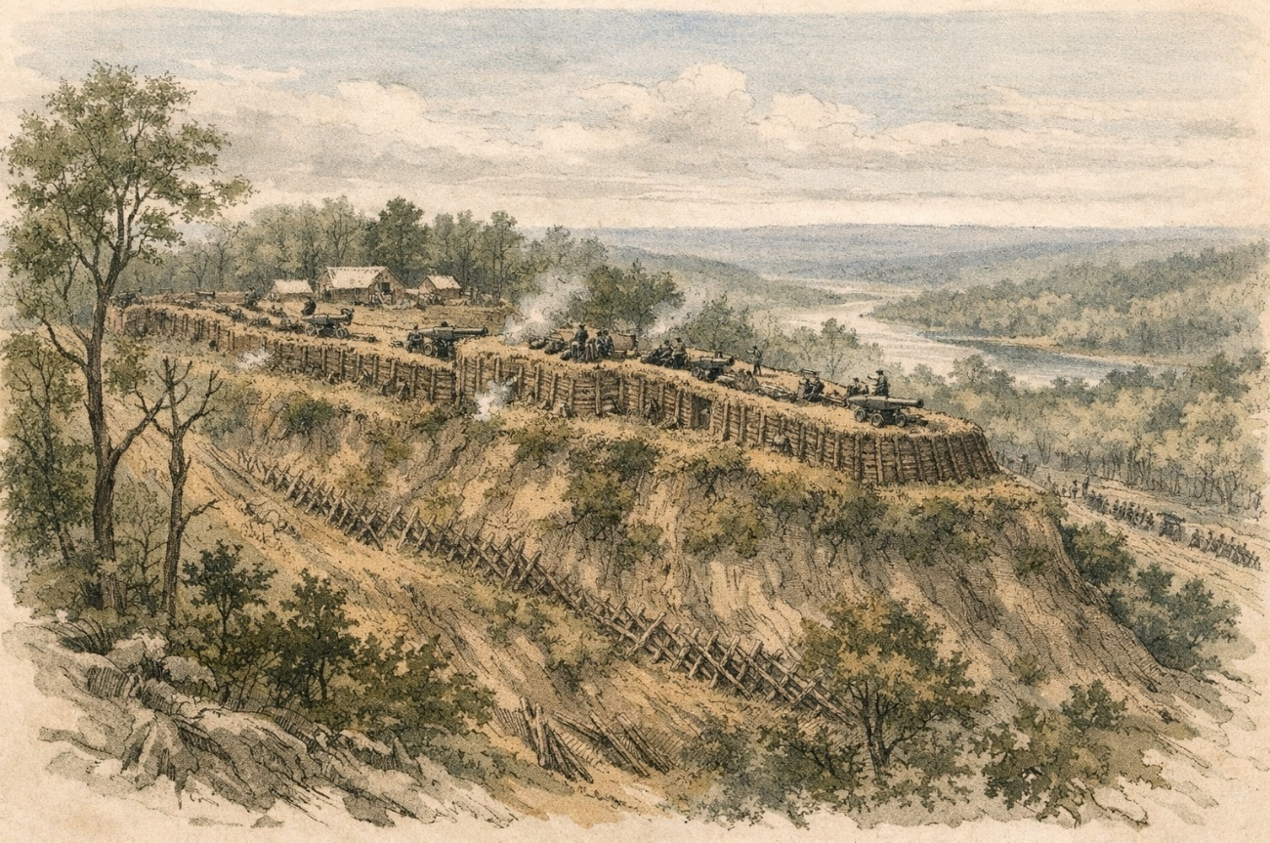

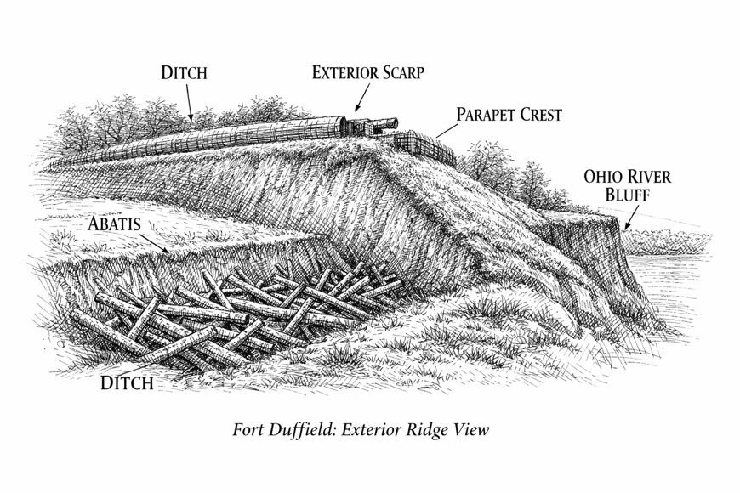
Figure 4.1 — Exterior Ridge View, Fort Duffield | Artist's Interpretive Sketch |
The exterior ridge view of Fort Duffield presents the observer — positioned south of the fortification, on the open ground that once formed the cleared killing field — with one of the most instructive perspectives available for understanding Civil War earthwork engineering. From this vantage point, the full profile of the primary defensive obstacle is visible as an attacker would have encountered it.
In the foreground, the glacis — a gently downward-sloping plane of earth extending from the forward lip of the ditch — presents a deceptively open appearance. The glacis is designed precisely to deceive: it appears passable, even inviting, while exposing any figure on its surface to the full fire of the garrison on the parapet crest. The slope of the glacis is calculated so that the defenders' line of fire reaches the ground precisely at the ditch lip, leaving no protected ground immediately in front of the ditch. In the original operational period of the fort, this glacis was backed by the full one-mile cleared field of fire — an open expanse giving defenders an extended engagement range against any approaching force.
At the base of the glacis lies the ditch — a horizontal excavation of approximately 8–12 feet in width, cut into the ridgetop soil and deepened to achieve the documented 17-foot total vertical relief from parapet crest to ditch floor. The ditch is the decisive obstacle of the exterior works. Any attacker who has crossed the glacis under fire must now descend into and ascend from the ditch — both movements executed under point-blank fire from the parapet crest above. The sides of the ditch are the scarp (the near-vertical inner face, presenting toward the attacker) and the counterscarp (the inner face adjacent to the parapet base, which the attacker must scale to reach the parapet itself). The scarp is typically the steeper of the two faces and is cut to prevent easy climbing.
The abatis — masses of felled trees with branches trimmed to points, interlaced and placed in and around the ditch — presents the next obstacle. Abatis functions as the Civil War equivalent of modern barbed wire: it slows movement, canalizes attackers into concentrated groups, and holds them in the most exposed and dangerous ground immediately below the parapet while the garrison delivers fire. At Fort Duffield, the surrounding timber provided abundant raw material for abatis construction, and period accounts confirm its emplacement.
Rising above the ditch and counterscarp is the exterior slope of the main parapet — the escarp face as seen by the attacker. This face rises at approximately 45 degrees from the counterscarp base to the parapet crest, presenting a steep, compacted earthen slope of 9 feet in height (the above-ditch portion of the parapet). The surface of this slope was compacted, and in some fortifications packed with cut sod or timber revetment to resist erosion and maintain the slope angle. At the crest, the parapet wall is 9 feet wide — giving it both stability and resistance to artillery fire. The parapet crest appears as a relatively narrow horizontal line from the exterior, minimizing its silhouette to enemy fire while providing a stable platform for defenders above.
To either side of the observer, the serpentine trace of the wall extends along the ridgeline, and it is possible — in the right light — to see how the angles of the trace are arranged to allow defenders at each position to fire obliquely along the exterior face of adjacent wall segments, denying attackers shelter at the base of any portion of the works.

4.2 Interior Ridge View Description

Interior Ridge View — Artist's Interpretive Sketch

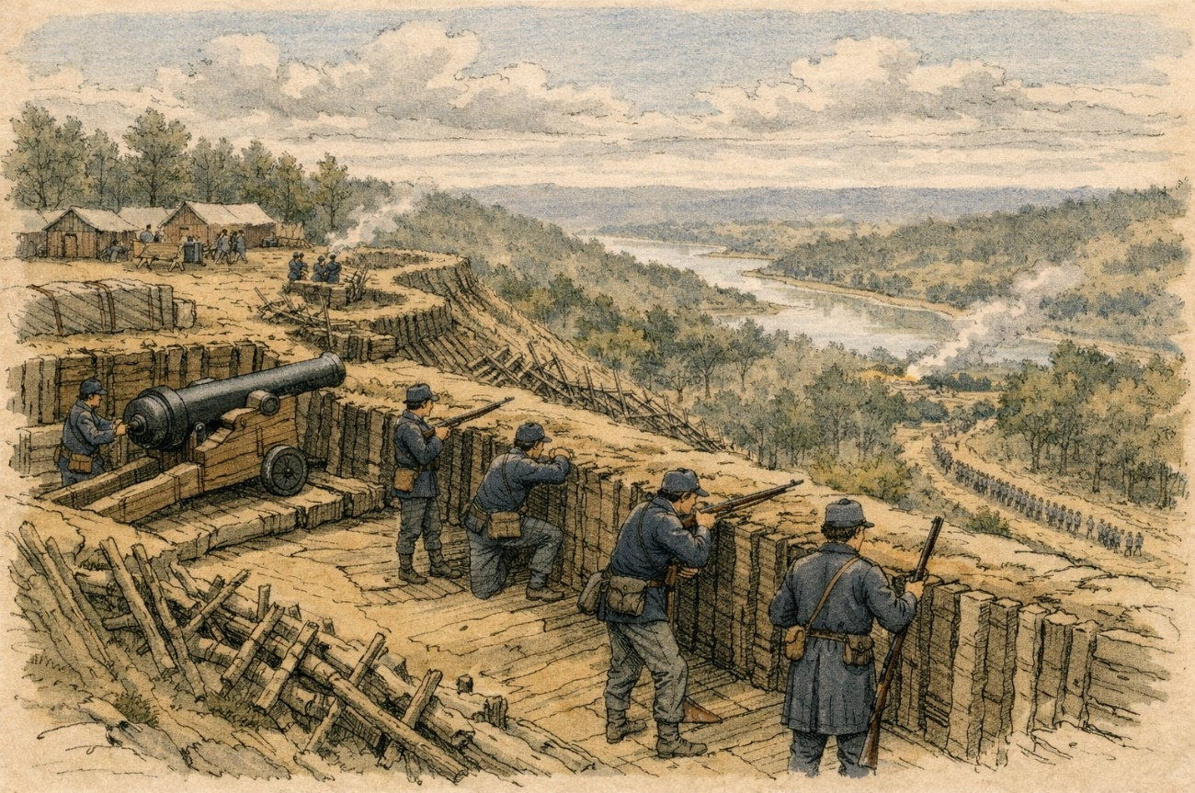
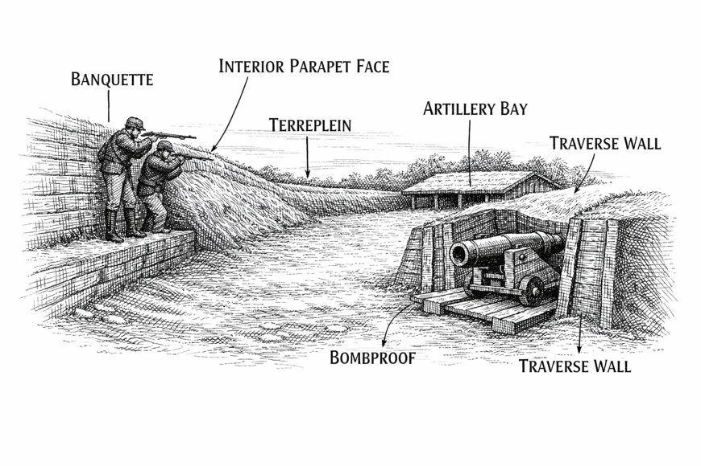Figure 4.2 — Interior Ridge View, Fort Duffield | Artist's Interpretive Sketch
The interior view of Fort Duffield reveals the organized military landscape within the enceinte — the functional world of the garrison during the fort's operational period in the winter of 1861–1862. This perspective, looking southward from a point within the enclosed area toward the interior face of the main parapet, discloses the engineering logic of the position as it was designed to be inhabited and operated.
The most immediate feature from this interior vantage is the terreplein — the broad, relatively flat interior platform of the fort that constitutes the working floor of the position. The terreplein is the space from which the garrison operated: artillery crews maneuvered here, infantrymen formed and moved here, and the daily business of the garrison — drill, maintenance, rotation of watch — was conducted on this surface. At Fort Duffield, the terreplein occupies the natural summit of Pearman Hill, with the parapet wall rising along its southern, eastern, and western edges. The northern edge, toward the Ohio River, is bounded by the natural bluff face. The terreplein is not a flat plane of uniform elevation — small variations in grade reflect both the original ridge topography and the construction activities of the garrison — but it is sufficiently level to allow artillery pieces to be moved and positioned without difficulty.
Along the interior base of the parapet wall runs the banquette — a raised step or firing platform, typically 18–24 inches in height, that allows infantry riflemen to stand on the step, bring their weapons to bear over the parapet crest, and fire at approaching targets while remaining largely protected by the parapet mass above and behind them. The banquette at Fort Duffield is formed by the natural slope of the interior face of the parapet — the compacted earth of the parapet wall extends down from the crest at a gentler angle than the exterior face (typically 45 degrees on the exterior versus 25–30 degrees on the interior), creating the banquette step at its base where it meets the terreplein. Riflemen standing on the banquette at Fort Duffield could deliver fire over the crest while presenting only their heads and shoulders to enemy observation.
Visible from the interior are the artillery bays — defined intervals along the parapet wall where the parapet is cut with an embrasure (a tapered opening through the wall) and a timber-and-earth artillery platform is set into the terreplein level. Fort Duffield mounted ten artillery pieces. Each gun bay is separated from its neighbors by a traverse wall — an earthen barrier running perpendicular to the parapet face, typically 6–8 feet in height and 4–6 feet thick at the base. The traverse walls serve two functions: they protect adjacent battery crews from the blast and concussion of the firing gun, and they prevent a single shell entering along the parapet line from sweeping multiple gun positions. The arrangement of ten gun bays separated by traverses along the 1,000-foot serpentine trace creates a characteristic rhythm to the interior landscape — a series of protected alcoves, each containing a gun, its platform, and its crew.
Set into the lower slope of the parapet interior, accessible from the terreplein but partially recessed below it, are the magazine entrances — the entry passages to the underground ammunition storage chambers. The magazines themselves are framed timber boxes excavated into the earth, their roofs covered with compacted soil of sufficient depth to resist shell burst. Small, low entries — narrow enough to limit blast entry — open onto the terreplein with heavy timber doors or earth-and-timber barriers. The interior of a working magazine would have been dark, carefully maintained at low humidity, and holding the fort's supply of powder charges, projectiles, and fuzes organized by type for rapid distribution to the gun batteries.
Scattered across the interior terreplein, and in some cases adjacent to the exterior of the parapet wall, are the bombproof shelters — squat, earthen-roofed structures with low-clearance interior spaces, framed in timber, providing protection for off-duty garrison members during bombardment. Bombproofs are not comfortable quarters; they are functional life-safety structures, designed to keep men alive during an artillery engagement so they remain available to fight when needed. At Fort Duffield, the bombproofs would have been complemented by the log cabin cantonment established outside the earthworks proper for day-to-day garrison living.

4.3 Artillery Platform Cross-Section

Artillery Platform Cross-Section — Technical Diagram
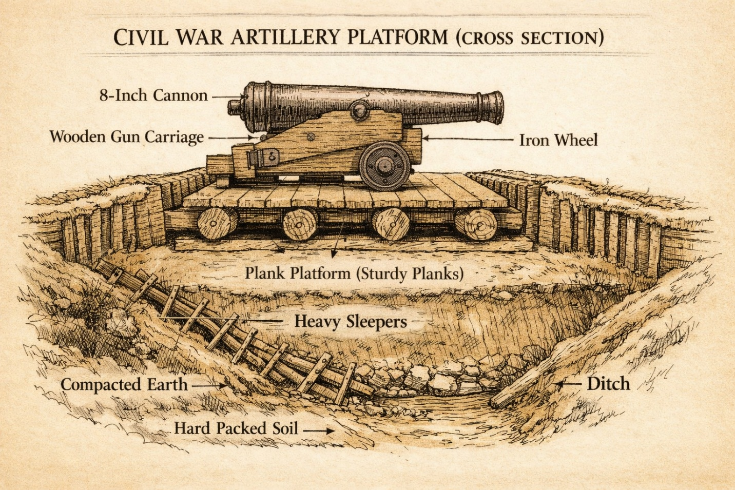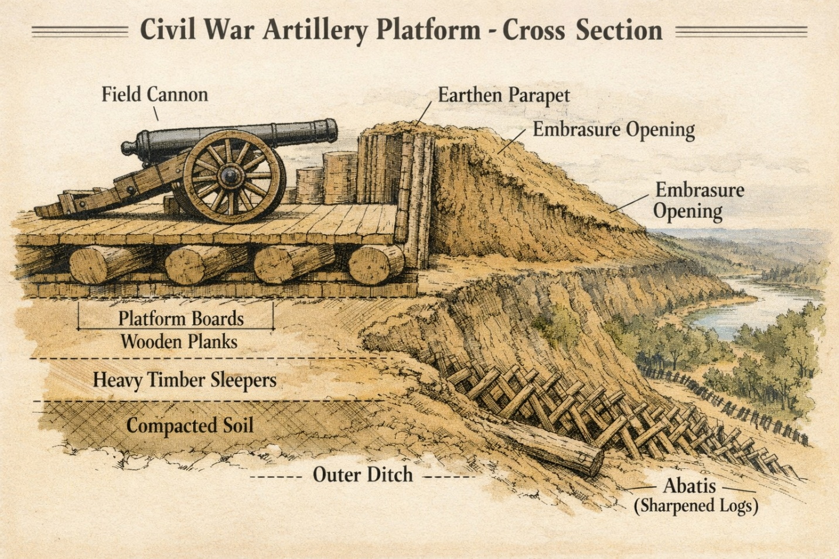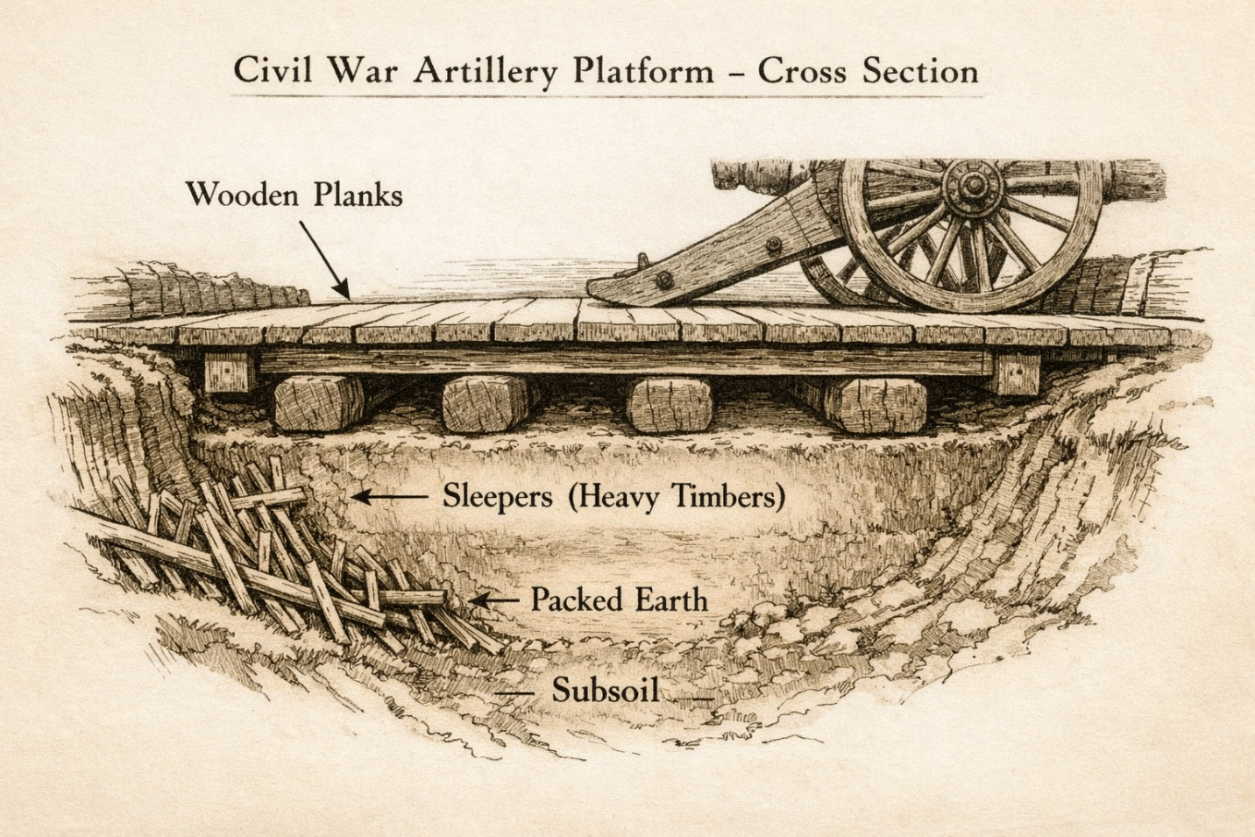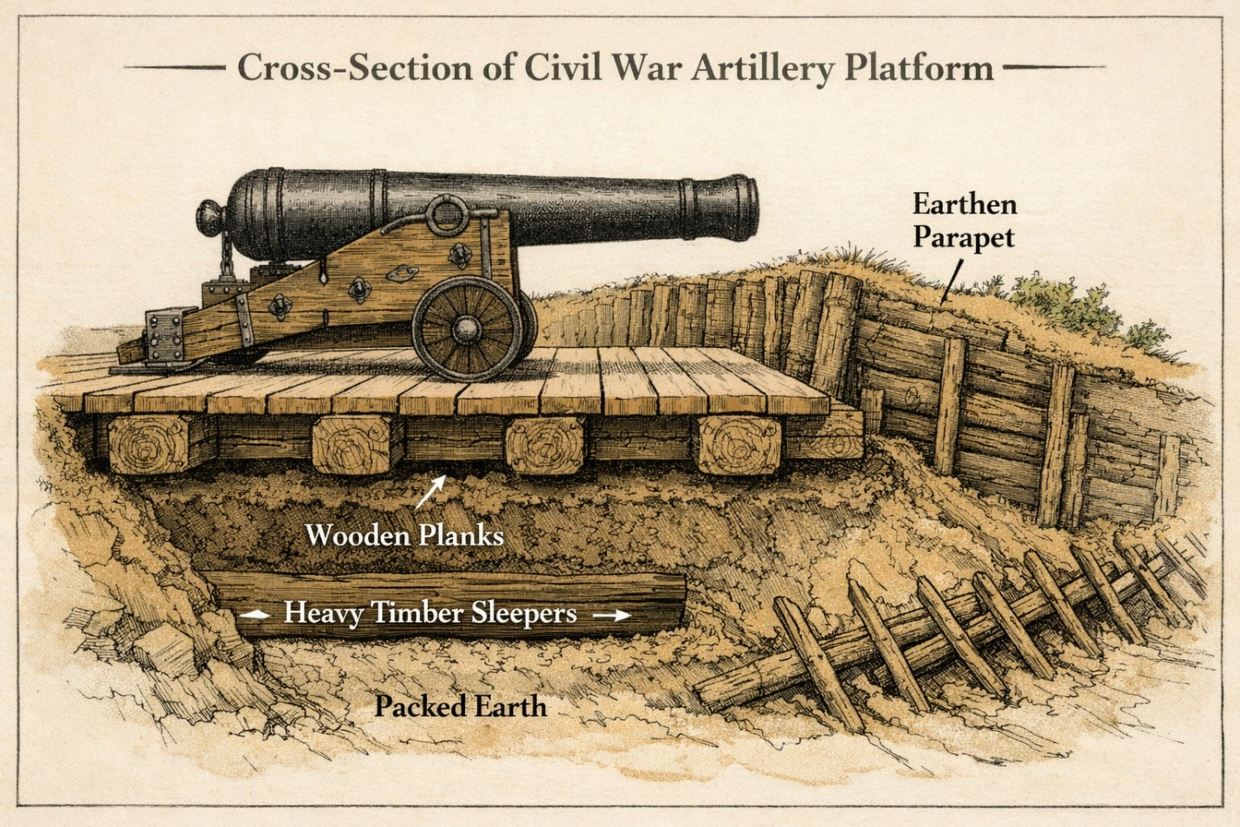

Figure 4.3 — Artillery Platform Cross-Section, Fort Duffield | Technical Diagram | [INSERT ARTWORK]
The artillery platform at Fort Duffield represents the intersection of engineering precision and field improvisation. Each gun position required a stable, level bearing surface for the artillery piece and its carriage, a defined arc of traverse, protected approaches for crew and ammunition handlers, and an embrasure through the parapet aligned with the platform's intended field of fire. The construction sequence and component specifications are described in detail below.
Subgrade Preparation: The natural earth of the Pearman Hill ridgetop was excavated to a depth of 6–12 inches below the desired final platform grade. The exposed subgrade was then examined for stability — soft or wet spots were excavated further and filled with compacted gravel or broken stone — and the resulting surface was hand-compacted. This preparatory step was essential: an uneven or soft subgrade would cause the platform to settle differentially under the repeated shock of artillery recoil, eventually shifting the gun out of alignment with the embrasure.
Timber Sill Layer: Heavy squared timbers — typically 8 inches by 8 inches or 10 inches by 10 inches in cross-section, hewn from locally sourced hardwood — were laid directly on the prepared subgrade, running perpendicular to the intended line of fire. These sills distributed the load of the platform and gun across a wider bearing area, preventing the point loads of the platform decking from punching into the subgrade under recoil loads. The sills were laid at intervals of approximately 18–24 inches on center.
Platform Decking: Close-laid planks of 2–3 inch thickness, cut from locally sourced hardwood (oak or poplar being the most available in the Hardin County area), were laid across the sills parallel to the line of fire, forming the operating surface of the platform. The planks were pinned or spiked to the sills and butted tightly to minimize gaps that could catch gun carriage wheels during recoil. The total platform surface was typically 14–16 feet in width and 12–15 feet in depth, providing adequate operating space for the gun, carriage, and crew.
The Traversing Arc: At the forward (embrasure) end of the platform, a curved timber or iron rail — the traversing arc — was set into the platform surface or attached to the forward sill. The gun carriage's front wheel or pivoting axle rode on this arc, allowing the artillery piece to be rotated (traversed) across a range of azimuths without having to completely reposition the heavy platform. The arc radius was calculated to center the gun's rotation on the pivot point of the mounting, allowing coverage of the designated field of fire from the assigned embrasure position.
The Embrasure: The embrasure — the opening cut through the parapet wall at the gun position — was designed with a pronounced outward splay: narrow at the inner (interior) face of the parapet wall, wider at the outer (exterior) face. This geometry served two purposes: it allowed the gun to traverse through a useful angular range while the muzzle remained within the opening, and it minimized the size of the opening visible to an enemy gunner attempting to fire through it. The cheeks of the embrasure (the sloped earth faces on each side) were reinforced with timber framing or compacted sod to resist erosion and maintain the opening dimensions under service conditions.
Recoil Path: Civil War artillery pieces recoiled several feet on firing — a 12-pounder Napoleon might recoil 3–4 feet, a heavier piece more. The platform was given a very slight rearward slope — perhaps 1 inch per foot — to aid controlled recoil and to facilitate running the gun back into battery position after each shot. Without this slope, recoil would be partially arrested by the platform surface, increasing shock loads on the carriage and crew; with it, the gun rolls back smoothly and returns to battery position under its own modest momentum.

4.4 Fort Profile Cross-Section

Fort Profile Cross-Section — Technical Diagram

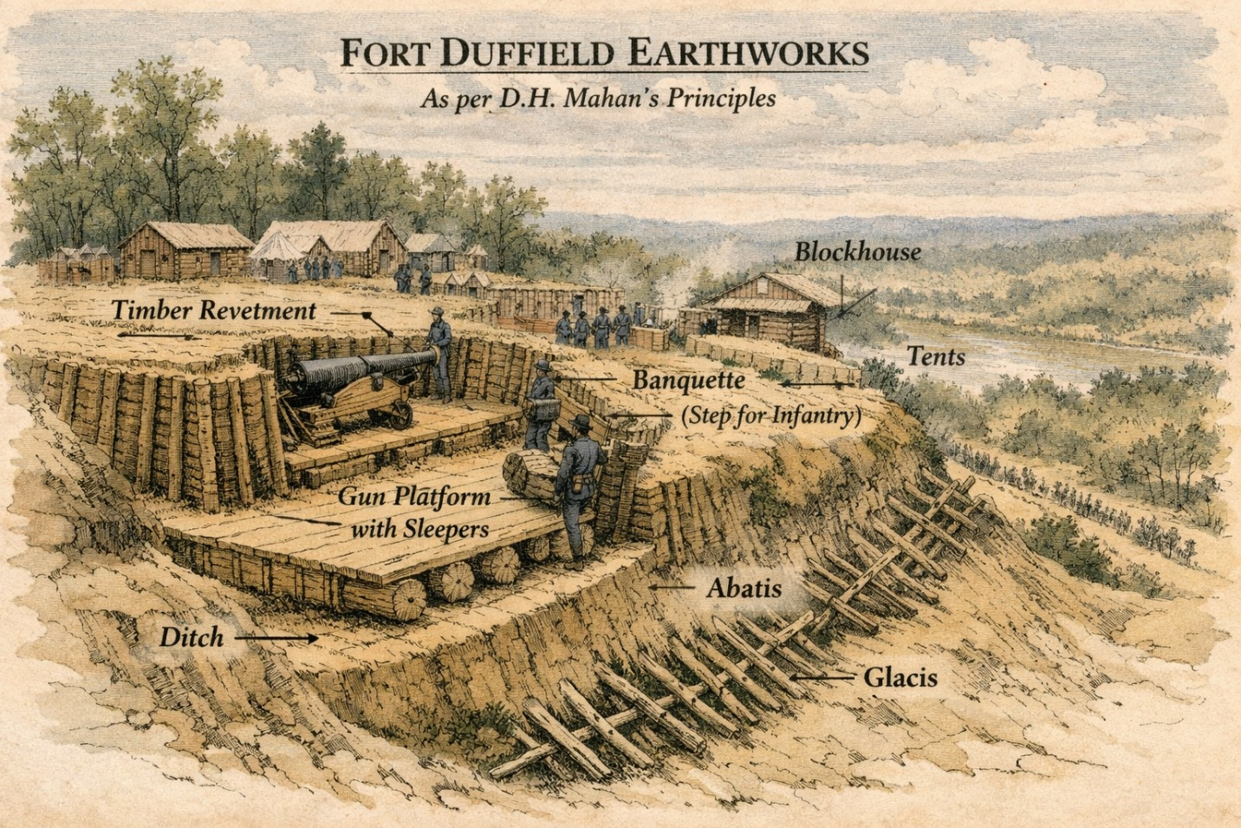
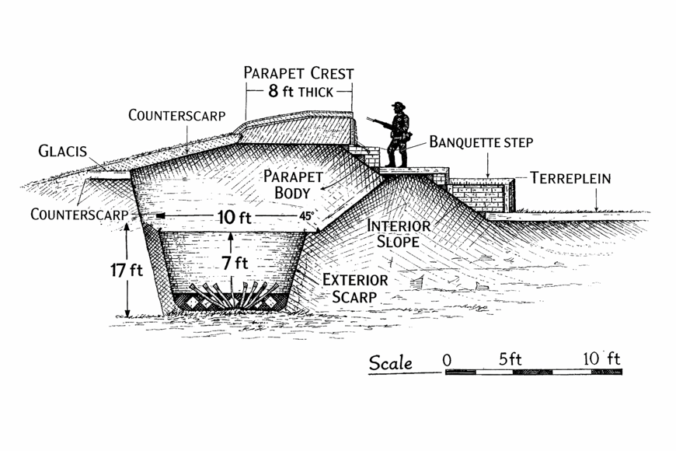Figure 4.4 — Full Fort Profile Cross-Section, Fort Duffield | Technical Engineering Diagram
A complete cross-section through the main parapet at Fort Duffield reveals the full stack of defensive engineering embodied in this 1861 earthwork. Reading from exterior to interior, the component elements are as follows:
- Glacis: The outermost element — a gently forward-sloping earthen ramp that exposes approaching forces to parapet fire while concealing the ditch until the last moment. At Fort Duffield, the original one-mile cleared field of fire extended the functional glacis concept across the entire southern approach.
- Ditch (Fosse): Cut into the Pearman Hill ridgetop soil immediately in front of the scarp; approximately 8–12 feet in width at base, contributing to the total 17-foot vertical relief documented by Captain DeLand. Abatis emplaced within and around the ditch.
- Counterscarp: The inner face of the ditch on the exterior side — the vertical or near-vertical earth face at the base of the scarp. The counterscarp presents a climbing obstacle to any attacker who has crossed the ditch floor.
- Exterior Slope (Scarp / Escarp): The face of the main parapet as seen from outside — rising at approximately 45 degrees from the counterscarp base to the parapet crest. At Fort Duffield, this slope rises approximately 9 feet above the base of the ditch.
- Parapet Crest: The topmost surface of the parapet wall — 9 feet wide per Captain DeLand's documented dimensions. This width provides stability against artillery fire, space for defenders to move along the crest, and resistance to collapse under shell burst.
- Banquette Slope: On the interior face of the parapet, a step or slope cut into the compacted earth allowing defenders to stand at the inner base of the wall and bring their rifles to bear over the crest. At Fort Duffield, the banquette was formed by the natural slope of the interior parapet face.
- Interior Slope: The inner face of the parapet, sloping at a gentler angle than the exterior face — typically 25–30 degrees — from the parapet crest down to the banquette and terreplein.
- Terreplein: The interior operating floor of the fort — the level or near-level surface of the Pearman Hill ridgetop enclosed within the earthwork trace. The terreplein is the working space of the garrison and the base surface for artillery platforms.
- Total Vertical Relief: Per documented sources, 17 feet from the top of the parapet crest to the bottom of the ditch — a formidable obstacle by any military standard, consistent with Mahan's prescriptions for a major field work.

Section 5Fort Duffield Comparison Chart

5.1 Fort Duffield in Context: Comparison with Comparable Civil War Earthworks

The following table provides a comprehensive comparison of Fort Duffield against three other significant Civil War earthwork fortifications: Fort Anderson (Brunswick County, North Carolina), Fort Donelson (Dover, Tennessee), and Fort Henry (Stewart County, Tennessee). These three comparison sites were selected because each represents a distinct variant of Civil War river-defense earthwork engineering, each operated in a comparable strategic role, and collectively they illustrate the range of design approaches, construction standards, and outcomes that characterize this category of Civil War fortification. Research data for the comparison sites is drawn from established historical sources including the Tennessee Encyclopedia, the North Carolina Historic Sites program, the Fort Donelson National Battlefield records, and the FortWiki historic forts database.

Feature | Fort Duffield (West Point, KY) | Fort Anderson (Brunswick County, NC) | Fort Donelson (Dover, TN) | Fort Henry (Stewart County, TN)
Construction Date | November 3, 1861 – January 1862; formally complete by January 1, 1862 | Construction began March 24, 1862; expanded through 1862–1864 | Summer 1861; expanded early 1862 before the February 1862 battle | Summer 1861; completed by autumn 1861 by Tennessee state engineers
Builder (Side) | Union Army — 9th Michigan Infantry and 37th Indiana Infantry, under General W.T. Sherman's orders | Confederate — built by North Carolina soldiers, enslaved laborers, free Blacks, and Native Americans; supervised by Lt. Thomas Rowland; named for Brig. Gen. George B. Anderson | Confederate — built initially by Tennessee Confederates; named for Confederate Gen. Daniel S. Donelson; Confederate engineers under Bushrod Johnson | Confederate — built by Tennessee state engineers; named for Confederate Senator Gustavus Henry of Clarksville, TN
Primary Strategic Purpose | River-traffic control (Salt R./Ohio R. confluence); protect the Louisville & Nashville Turnpike corridor; anchor Union supply base at West Point for Elizabethtown operations | Block Union naval access up the Cape Fear River to Wilmington, NC — a critical Confederate port and blockade-running terminus | Control the Cumberland River approach to Nashville; protect the interior of Tennessee; serve as a Confederate defensive anchor in the Western Theater | Control the Tennessee River; defend the critical railroad connecting Bowling Green, KY to Memphis, TN; serve as part of the Confederate river-defense system
Terrain Type | High bluff top (Pearman Hill) above river confluence; commanding elevation; ridgeline terrain | Low bluff on the west bank of the Cape Fear River atop ruins of colonial Brunswick Town; river channel forces ships close to the guns | High bluff (approx. 100 ft.) above the Cumberland River; ridge and ravine terrain; dense woodland | Low ground adjacent to the Tennessee River — poorly sited; subject to river flooding; no commanding elevation advantage
Primary Armament Type | Mix of smoothbore and rifled field artillery; 10 guns documented; calibers not precisely recorded in available primary sources | Heavy seacoast artillery and field pieces; smoothbore 32-pounders; rifled 32-pounders; 128-pounder; total dozens of guns in the expanded fort; L-shaped river battery with 5 gun emplacements plus additional batteries | Heavy artillery on river bluff battery; 128-pounder and 32-pounder cannon documented; plus land-defense cannon and field pieces in the outer works | 17 guns of various types; smoothbore cannon; described as "antiquated" and limited in effectiveness; fort mounted guns at or near river level with no height advantage
Garrison Size (Approximate) | Approximately 950 troops at peak; 9th Michigan Infantry and 37th Indiana Infantry; garrison reduced in late 1861 as units moved south | Variable garrison throughout the war; Confederate forces expanded; final Confederate garrison evacuated February 19, 1865 | Approximately 15,000–17,000 Confederate troops concentrated for the February 1862 battle; original construction garrison considerably smaller | Approximately 3,400 Confederate troops under Gen. Lloyd Tilghman at time of engagement; 70 artillerymen remained for the defense while the rest withdrew to Fort Donelson
Parapet Height / Dimensions (Approximate) | 9 ft. wide at parapet crest; 17 ft. total vertical relief from crest to ditch floor; approximately 20–30 ft. overall earthwork height above base (eroded from original); 1,000-foot trace length | Walls 6–10 ft. high in original construction; expanded by Maj. Lamb to 24 ft. on the river battery; buffer traverses 26 ft. high; trace nearly one mile long (Cape Fear River to Orton Pond) | Log-and-earth walls up to 8 ft. high and 20 ft. thick at base in the land defense works; river battery on 100-ft. bluff; two-mile arc of perimeter | Earthen works at or near river level; no significant height advantage; ditch documented as flooding with river water at time of attack; specific parapet dimensions not consistently recorded
Design Doctrine | Mahan-derived Union field fortification doctrine; serpentine wall trace following ridgeline; open on the bluff face; artillery-primary design for river defense; ten "angles of fire" | Confederate adaptation of European river-defense principles; heavy seacoast artillery emphasis; L-shaped river battery backed by traverses; bombproofs under earthworks; expanded iteratively by successive commanders | Confederate field fortification doctrine — Tennessee state engineers; water battery on bluff for river defense; extended land-defense rifle pits and breastworks in "three-mile arc" around Dover; essentially hybrid land/river defense design | Confederate — five-sided earthwork design; poorly executed siting on low ground; no elevation advantage for guns; garrison camp adjacent but not integrated into main works; essentially a water battery without effective terrain support
Ditch Present? | Yes — cut into the ridgetop; contributing to 17-ft. total vertical relief; abatis emplaced in and around ditch | Yes — deep ditch documented on the north battery: "a deep ditch in the rear" per NC Historic Sites; ditch protected by traverses | Yes — ditch and rifle pits documented in the outer land-defense works; river battery relied on bluff elevation rather than ditch | Yes — ditch documented in "Profile of fort ditch full of water" per Library of Congress map notation; the ditch flooded with Tennessee River backwater prior to the engagement
Bombproofs Present? | Yes — constructed within the enceinte to shelter off-duty garrison during bombardment; timber-framed with earthen overhead cover | Yes — beneath some of the earthworks; described in NC Historic Sites documentation as "shelters used by troops during enemy bombardment" | Yes — log hut garrison camp within the arc; bombproofs documented in the land-defense works | Not prominently documented in primary sources; the fort's rapid fall (approx. 1 hour 15 minutes of engagement) suggests limited development of interior shelter
Result / Fate | Never engaged in combat; abandoned mid-December 1862 as the war moved south; ironically, Morgan's Raiders passed nearby in 1863 after abandonment | Successfully defended Confederate supply lines until February 1865; captured by Union forces February 17–19, 1865 in a combined land-and-sea assault; subsequently used as refugee housing for African Americans following Sherman's march | Scene of major engagement, February 11–16, 1862 (Battle of Fort Donelson); Confederate surrender of approximately 13,000 troops to U.S. Grant; Grant's "Unconditional Surrender" demand; first major Union victory of the war | Captured by Union naval forces February 6, 1862 (Battle of Fort Henry) in approximately 1 hour 15 minutes; Gen. Tilghman sent bulk of garrison to Fort Donelson; 70 artillerymen surrendered to Flag Officer Foote; original fort site now submerged beneath Kentucky Lake
Preservation Status Today | Excellent — one of Kentucky's best-preserved Civil War earthworks; listed NRHP January 31, 1994 (Ref. No. 93001584); managed by Fort Duffield Heritage Committee; open to public; archaeological investigation conducted 1997 | Good — managed as Brunswick Town / Fort Anderson State Historic Site (NC); visitor center opened 1967; ongoing archaeological excavation; earthwork features visible; well-interpreted | Excellent — Fort Donelson National Battlefield (NPS); earthworks, river battery, and Dover Hotel (surrender site) preserved; extensive interpretive program; outstanding NRHP status | Lost — original fort site completely submerged beneath Kentucky Lake (Tennessee Valley Authority impoundment); only outer earthworks (rifle pits) remain accessible at land surface via Fort Henry Trail, Land Between the Lakes NRA
Key Lesson / Distinctive Feature | Demonstrates terrain-driven adaptation of Mahan doctrine; serpentine trace unique among Kentucky forts; never tested in combat — pristine engineering record; freshwater spring within fort perimeter; oldest Union fortification in Kentucky | Demonstrates incremental Confederate engineering: fort expanded and improved by successive commanders; massive river battery walls (24 ft.) reflect lessons learned from Fort Henry and Fort Donelson; successfully protected Wilmington for nearly 3 years of the war | Demonstrates both the strengths (successful river battery action February 14) and catastrophic weaknesses (command confusion, failed breakout) of Confederate Western Theater fortification strategy; Grant's siege approach and flexibility neutralized the land-defense perimeter | Classic example of catastrophic siting failure: a well-intentioned fortification rendered untenable by terrain choice (low ground subject to flooding) and resulting inability to achieve gun-height advantage over naval vessels; contrast sharply with Fort Duffield's commanding bluff position

5.2 Analysis: What Fort Duffield's Design Tells Us

The comparison table above illuminates several important dimensions of Fort Duffield's design choices and their relationship to Union engineering priorities in the Western Theater during 1861–1862. The most immediately striking contrast is between Fort Duffield and Fort Henry: where Fort Henry's designers sited their work on low ground subject to inundation — with catastrophically fatal consequences for the fort's defensive effectiveness — Fort Duffield's designers placed their work on the highest available terrain, achieving the commanding elevation that Mahan's doctrine identified as the foundational requirement of any defensible position. The contrast is not one of doctrine but of execution: the same principles were available to both Union and Confederate engineers, and the difference between Fort Duffield's commanding bluff and Fort Henry's flood-prone river bank was a difference in the quality of the terrain-analysis judgment applied by the engineers on the ground. Fort Duffield's designers got it right; Fort Henry's designers made a decision that contributed directly to the fort's rapid defeat.
The comparison with Fort Anderson reveals how differently the river-defense mission played out in different theaters and at different operational scales. Fort Anderson's walls, eventually reaching 24 feet in height on the river battery under Major Lamb's expansions, dwarf Fort Duffield's 9-foot parapet crest — but Fort Anderson was designed to stop heavy naval gunfire from Union ironclads mounting weapons of far greater destructive capacity than any force Fort Duffield ever anticipated. Fort Duffield's 10 guns, relatively modest parapet dimensions, and compact 1,000-foot trace reflect a threat environment of Confederate infantry advance and river gunboat harassment — a fundamentally different engineering requirement than the Cape Fear River naval corridor that Fort Anderson was built to dominate. Both forts are correctly designed for their respective missions; their differences are those of mission profile, not of engineering competence.
Fort Duffield's current preservation status — among the best of the four sites compared — tells a story about the relationship between obscurity and survival. Fort Henry was destroyed by the TVA impoundment; Fort Donelson and Fort Anderson, as major battle sites, received NPS and state management that brought preservation but also heavy visitation infrastructure. Fort Duffield, which never saw combat and was never a famous battle site, was left largely alone after its abandonment in 1862. The forest grew back around it; no development occurred on Pearman Hill; the earthworks eroded gently under a century of rainfall but were never cut by roads, built upon, or excavated for development. This benign neglect, supplemented by the active preservation efforts of the Fort Duffield Heritage Committee since 1995 and the NRHP listing of 1994, has left the site with a physical integrity that many battle-site earthworks have lost to the infrastructure of commemoration. Fort Duffield's status as a pristine engineering record — a fortification built, used briefly, and then left to the Kentucky hills — is among its most historically valuable characteristics.

Section 6 The Louisville & Nashville Turnpike: Transportation Context

6.1 The Turnpike, Not the Railroad

⚠ HISTORICAL CLARIFICATION — TRANSPORTATION AT WEST POINT, KY (1861–1863)
The Louisville & Nashville Railroad did NOT pass through or serve West Point, Kentucky during the Civil War. The railroad's main line ran east of West Point through different terrain — through Elizabethtown, Munfordville, Glasgow Junction, and southward to Nashville — and was not a feature of the transportation environment at West Point itself.
The transportation corridor directly relevant to Fort Duffield and the West Point position was the Louisville & Nashville Turnpike — a macadamized (compacted crushed-stone surfaced) toll wagon road that had been constructed beginning in 1837 and reached completion of its primary sections by 1849. This turnpike — the forerunner of what is now US Route 31W — ran from Louisville, Kentucky southward through Elizabethtown, Munfordville, Glasgow Junction (Park City), Bowling Green, and Franklin, then into Tennessee to Nashville. It was one of the best-improved roads in Kentucky in 1861 and served as the primary overland supply and communication route for Union forces operating south of Louisville in the early war period.
Fort Duffield's placement at West Point was specifically designed to protect and control this turnpike corridor. All references to "the road," "the turnpike," or "the supply route" in period documents relating to the West Point position refer to this wagon road. The L&N Turnpike Corridor Segment near West Point is itself listed on the National Register of Historic Places (1996), recognizing its significance as a transportation and Civil War military route.
Note: Some historical markers and secondary sources reference the L&N Railroad in connection with the West Point/Fort Duffield area, but these references relate to the railroad's broader strategic significance to Union operations in Kentucky — not to a railroad line through or at West Point itself. Researchers should distinguish carefully between references to the railroad (which ran through Elizabethtown, approximately 25 miles to the south) and references to the turnpike (which passed through West Point). The Kentucky Historical Society marker for Fort Duffield references the L&N Turnpike ("the Union line of supply via the L&N Turnpike") as the protected route — this is the correct reading.

6.2 The Turnpike's Military Significance

The Road Surface and Its Importance
The Louisville & Nashville Turnpike was among the most improved roads in Kentucky during the antebellum period. Macadamized — surfaced with layers of carefully graded, compacted broken stone following the principles of Scottish road engineer John Loudon McAdam — the turnpike provided a relatively reliable all-weather surface for wheeled traffic. This was of enormous military significance in an era when the mobility of armies depended almost entirely on the trafficability of roads for wagon trains, artillery, and marching infantry. An unimproved dirt road in Kentucky in November 1861, under the rainfall conditions typical of the autumn season, would be a quagmire capable of halting an army; the macadamized turnpike remained passable under conditions that would immobilize traffic on unimproved surfaces.
The turnpike was structured as a toll road, with toll booths approximately every five miles along its length — a financing mechanism that also created an administrative infrastructure for the road. Travel from Louisville to Nashville by stagecoach on the turnpike took approximately three days under good conditions. Military wagon trains, moving at slower speeds and with heavier loads, would have taken longer, but the road surface made the movement feasible year-round in a way that unpaved alternatives could not guarantee.

Fort Duffield's Relationship to the Turnpike
West Point sits at the point where the Louisville & Nashville Turnpike reached the Salt River crossing — a critical pinch point in the road corridor. Any force using the turnpike to move between Louisville and Elizabethtown necessarily crossed the Salt River at or near West Point. Fort Duffield, positioned on the commanding heights above this crossing, dominated the road and its critical bridge or ford crossing simultaneously with its domination of the river approaches. An enemy force seeking to interdict the turnpike supply line would have had to either bypass Fort Duffield entirely (accepting a long detour over worse terrain) or engage the fort directly — a costly proposition given its commanding position.
General Sherman's logic in establishing West Point as a supply base and building Fort Duffield to protect it was precisely this: the Ohio River could supply West Point by water from Louisville; West Point could then supply the Elizabethtown garrison overland via the macadamized turnpike; and Fort Duffield could guarantee the security of both the water supply approach and the road supply corridor simultaneously. It was a logistically elegant solution to the problem of sustaining forward Union forces in the opening months of the Kentucky campaign.

The Turnpike vs. the Railroad: A Critical Distinction
The Louisville & Nashville Railroad, completed in 1859, ran parallel to the turnpike in a general sense — both connected Louisville to Nashville — but the railroad followed a different alignment, routed through Elizabethtown rather than through West Point. The railroad's completion in 1859 had actually diminished traffic on the turnpike (which entered a period of decline after 1859 as it lost freight and passenger business to the railroad), but the military value of the turnpike as a supply artery remained significant in the Civil War period, particularly for operations in areas not directly served by the railroad line. Confederate forces seeking to threaten the L&N Railroad line would logically have focused on Elizabethtown and Munfordville — not on West Point, which was not on the railroad route. Fort Duffield's mission was the protection of the turnpike, not the railroad.
The distinction matters for historical interpretation because the two transportation corridors had different strategic implications, different vulnerability profiles, and different sets of actors interested in their protection or interdiction. Conflating the railroad and the turnpike in the West Point context produces a distorted picture of why Fort Duffield was built where it was and what it was designed to do. The fort's commanding position on Pearman Hill makes complete sense as a turnpike and river crossing defense; it makes no sense at all as a railroad defense, since the railroad was not there.

Section 7 Interpretive Analysis and Conclusions

7.1 Fort Duffield as a Type Specimen

In the vocabulary of natural history, a "type specimen" is the physical example by which a species or category is formally defined — the reference object against which all similar examples are measured. Fort Duffield occupies an analogous role in the history of Civil War Union river-defense earthwork fortification in the Western Theater. As the oldest Union fortification in Kentucky, constructed at the very beginning of the Union presence in the Commonwealth, built to a design that reflects early-war engineering thinking before the lessons of major battles had fundamentally altered fortification doctrine, and preserved to a degree that allows direct physical examination of its features, Fort Duffield is the type specimen of its category.
As a type specimen, Fort Duffield illustrates three critical aspects of early-war Union field fortification practice. First, it demonstrates the rapid and competent translation of Mahan's academic principles into field construction. The 9th Michigan Infantry, a regiment of Michigan volunteers with no prior military construction experience as an organized unit, produced a fortification of documented dimensions (17 feet of vertical relief, 9 feet of crest width, 10 artillery positions, a 1,000-foot trace) that conform to Mahan's specified standards for a major field work. This was not an accident — it was the product of the Military Academy's systematic dissemination of engineering doctrine through its officer graduates, who then translated that doctrine into work details and construction sequences on a Kentucky hillside.
Second, Fort Duffield illustrates the adaptation of standard trace geometry to irregular bluff terrain. The serpentine wall is not found in Mahan's textbook diagrams, but it is the logical product of applying Mahan's principles — command, flanking fire, economy of garrison — to a sinuous ridgeline rather than a flat open field. Fort Duffield teaches that doctrine, applied intelligently, produces adapted solutions rather than cookie-cutter copies of textbook designs. This is a lesson that has resonance well beyond the specific history of the fort.
Third, Fort Duffield illustrates the integration of river artillery defense with overland road protection in a single fortification. The fort was not designed to do one thing — it was designed to simultaneously command the Salt River, dominate the Ohio River corridor, cover the turnpike crossing at West Point, and secure the supply base below. This multi-mission design, expressed in a single compact earthwork, reflects the strategic complexity of the Western Theater's river-road network and the engineering sophistication required to address it.

7.2 What Survives and What It Tells Us

The earthworks of Fort Duffield are today among the most physically legible Civil War fortifications in Kentucky — a status that is the direct result of the site's history of non-engagement and subsequent non-development. The serpentine wall, running approximately 1,000 feet along the summit of Pearman Hill, remains visible and traceable. The earthwork profile, though reduced by 160 years of rainfall erosion and natural settling from its 1861–1862 dimensions, still presents impressive relief — documented in recent interpretive materials as "approximately 20 to 30 feet high" in the most prominent sections (reflecting the combined height of the parapet above the natural ridge surface, including the effects of erosion from the original constructed dimensions). The trace is sufficiently preserved that a visitor following the marked path can read the angles of the serpentine wall, identify the approximate positions of the artillery bays, and understand the relationship between the fort's profile and the ground it commanded.
The 1997 archaeological investigation — conducted by the Program for Archaeological Research, Department of Anthropology, University of Kentucky, funded in part by the Kentucky Heritage Council and the National Park Service, documented as Technical Report No. 418 — provided the first systematic physical examination of the fort's buried archaeology. While the full findings of that report are beyond the scope of this compilation, the investigation confirmed the physical integrity of the site's subsurface archaeological record, identifying features consistent with the construction activities documented in period accounts. A freshwater spring within the fort perimeter, noted in multiple period sources as a critical garrison resource, remains identifiable at the site today — a tangible connection to the lived experience of the 9th Michigan Infantry men who drew their water from it during the winter of 1861–1862.
The re-establishment of forest cover around the fort since its abandonment — replacing the original one-mile cleared field of fire with mature woodland — is the most significant change in the site's interpretive landscape. Modern visitors cannot see the commanding open view that existed in 1861–1862, when the garrison could observe any approaching force from the moment it emerged from the distant treeline. The Ohio River and Salt River confluence view from the northern bluff edge, however, remains accessible and is one of the site's most evocative interpretive features — the same view that Sherman's engineers assessed in the autumn of 1861 as justifying the entire fortification project.
The integrity of the earthwork profile is the site's most precious and fragile resource. Modern intrusions — paths cut through the parapet wall, infrastructure installations that alter the drainage patterns around the works, or even well-intentioned "improvements" that modify the earthwork surface — represent irreversible damage to a finite physical record. The Fort Duffield Heritage Committee's policy of directing visitors to marked trails and away from the earthworks themselves is the correct preservation posture. The earthworks must be observed, not walked upon or excavated without professional archaeological oversight.

7.3 Open Questions and Areas for Further Research

Despite the relatively rich documentary record associated with Fort Duffield — including the Wellington C. Wells diary (138 daily entries, October 1861 through March 1862), the DeLand letter regarding fort dimensions, and the records of the 9th Michigan Infantry — significant historical questions remain unanswered. The following research questions represent the most productive areas for future investigation:
1. Precise garrison size and unit rotations: What was the exact strength return of Fort Duffield at weekly or monthly intervals during its operational period (November 1861 – December 1862)? When precisely did the 37th Indiana Infantry depart, and what other units may have contributed to the garrison beyond the 9th Michigan? What was the garrison strength at abandonment?

2. Artillery inventory — types, calibers, and quantities: The "ten pieces of artillery" documented at Fort Duffield are not identified by type or caliber in available sources. Were they 6-pounder bronze field guns? 12-pounder Napoleons? Rifled 10-pounders? Heavy siege pieces? The artillery inventory has direct implications for the fort's actual offensive and defensive capability and deserves documentary resolution from regimental ordnance returns.

3. Documentary evidence of specific construction activities: The Wellington C. Wells diary is an exceptional primary source, but it represents one bandsman's perspective. Are there additional diaries, letters, or official reports from members of the 9th Michigan Infantry or the 37th Indiana Infantry that provide more granular documentation of specific construction work sequences, tool inventories, timber procurement, or engineering direction?

4. Combat activity and threat response: Fort Duffield never engaged in documented combat action. However, were there incidents — Confederate reconnaissance activity, guerrilla threats, or alarm responses — that produced official reports or correspondence? The "First Skirmish at West Point" documented as September 9, 1861, on the Fort Duffield Heritage Committee website predates formal construction — what was the nature of this engagement?

5. The exact trace of the Louisville & Nashville Turnpike through West Point in 1861: The general route of the turnpike is established, and a corridor segment near West Point is listed on the NRHP (1996). However, the precise alignment of the road through the town of West Point itself in 1861 — including the location of the Salt River crossing (bridge or ford) — requires additional documentary and cartographic research to establish definitively.

6. Archaeological survey status and subsurface findings: Technical Report No. 418 (1997 investigation) should be reviewed in full and updated. Has any subsequent archaeological work been conducted at the site? What specific features were identified in the 1997 investigation? Are there buried artifact deposits associated with the artillery positions, magazine locations, or bombproof sites that could yield additional information about the fort's equipment and garrison?

Section 8 Sources and Further Reading
The following bibliography presents the primary and secondary sources most relevant to the historical compilation above, organized by category. All sources are cited in their published or archival form. Researchers are encouraged to consult original primary sources wherever possible, as secondary sources — including some historical markers and popular histories — occasionally contain errors of fact regarding specific details of transportation routes, unit identifications, and construction timelines that are corrected by primary source examination.
I. Primary Sources — Official Records and Government Documents
The War of the Rebellion: A Compilation of the Official Records of the Union and Confederate Armies. Series I, Vol. IV (Operations in Kentucky, Tennessee, North Alabama, and Southwest Virginia: July 1, 1861 – March 31, 1862); Series I, Vol. VII (Operations in Kentucky, Tennessee, N. Alabama, and SW Virginia: October 8, 1861 – January 19, 1862). Washington, D.C.: Government Printing Office, 1882–1901. [Relevant volumes for the Ohio River / Kentucky Theater, 1861–1862. Available digitally through Cornell University Making of America project.]
U.S. Army Corps of Engineers. Historical records and maps pertaining to Western Theater fortifications, 1861–1865. Record Group 77, National Archives and Records Administration, Washington, D.C. [Includes engineering reports and fortification sketches for Kentucky and Tennessee river-defense works.]
Library of Congress, Geography and Map Division. [Plan of Fort Henry and its outworks.] Manuscript, pen-and-ink on cloth, 1864. Call No. G3964.F67S5 1862 .U5. [Includes profile sections showing the Fort Henry ditch, now flooded.]
Program for Archaeological Research, Department of Anthropology, University of Kentucky. Technical Report No. 418: Archaeological Investigation of Fort Duffield, West Point, Hardin County, Kentucky. 1997. [The primary archaeological investigation of the Fort Duffield site. Funded by the Kentucky Heritage Council and the National Park Service.]
II. Primary Sources — Diaries, Letters, and Unit Records
Wells, Wellington C. The Complete Wellington C. Wells Diary: From Fort Wayne, Michigan to Nashville, Tennessee. October 1861 – March 1862. 138 daily entries, fully annotated. Published/transcribed by the Fort Duffield Heritage Committee. [The only known daily diary of a 9th Michigan Infantry bandsman at Fort Duffield. Available through the Fort Duffield Heritage Committee website: fortduffield.com]
DeLand, Captain Charles V. Letter regarding Fort Duffield dimensions and construction, 9th Michigan Volunteer Infantry. Transcribed by Fort Duffield Heritage Committee. [Documents the 17-foot vertical relief (crest to ditch bottom) and 9-foot parapet crest width of the primary fortification.]
9th Michigan Infantry Regiment. Regimental history and service records. Available through the Michigan State Archives and the Bentley Historical Library, University of Michigan, Ann Arbor. [Includes unit diaries, muster rolls, and officer correspondence relevant to the West Point and Fort Duffield period.]
III. Engineering and Doctrine — Mahan and Field Fortification
Mahan, Dennis Hart. A Complete Treatise on Field Fortifications. New York, 1836. [First edition of the foundational Union field fortification text.]
Mahan, Dennis Hart. A Treatise on Field Fortification: Containing Instructions on the Methods of Laying Out, Constructing, Defending, and Attacking Intrenchments, with the General Outlines also of the Arrangement, the Attack and Defence of Permanent Fortifications. New York: John Wiley, 1860. [The Civil War-era edition, revised and expanded. Available digitally through the Library of Congress (Call No. UG403 .M212) and the Internet Archive. Also reprinted by West & Johnston, Richmond, Virginia, 1862, for Confederate use.]
National Park Service. "DC's Civil War Earthworks." Civil War Defenses of Washington, George Washington Memorial Parkway. Washington, D.C.: National Park Service, U.S. Department of the Interior. [Provides an accessible overview of Mahan's principles as applied to Civil War earthwork construction generally.]

IV. Fort Duffield Site and Local History
Fort Duffield Heritage Committee. Fort Duffield: Origins and Early History. West Point, Kentucky. [Available at fortduffield.com. The primary interpretive website for the site, including walking tour documentation, primary source transcriptions, and organizational history.]
Kentucky Historical Society. Fort Duffield Historical Marker, Marker Number 2449. North end of US Bus. 31W (Main St.), West Point, Hardin County, Kentucky. Dedicated August 8, 2015.
National Register of Historic Places. Fort Duffield.) NRHP Reference No. 93001584. Listed January 31, 1994. National Register nomination documentation available through the National Park Service NRHP database.
National Register of Historic Places. Louisville and Nashville Turnpike Corridor Segment. NRHP Reference No. 96000790. Listed July 31, 1996. Near West Point, Hardin County, Kentucky / Fort Knox Military Reservation. [Documents the turnpike alignment nearest to Fort Duffield and its significance for regional settlement, economic development, and Civil War military logistics.]
V. Comparative Site References — Fort Anderson, Fort Donelson, Fort Henry
North Carolina Historic Sites. "Fort Anderson — Purpose and Construction." North Carolina Department of Natural and Cultural Resources. Available at historicsites.nc.gov. [Primary interpretive documentation for Fort Anderson's construction history, dimensions, and armament.]
Cooling, B. Franklin. "Fort Donelson." Tennessee Encyclopedia of History and Culture. Tennessee Historical Society / University of Tennessee Press. [Standard reference for Fort Donelson history and the February 1862 engagement.]
Cooling, B. Franklin. "Fort Henry." Tennessee Encyclopedia of History and Culture. Tennessee Historical Society / University of Tennessee Press. [Standard reference for Fort Henry history, construction, and the February 6, 1862 capture.]
Cooling, B. Franklin. Forts Henry and Donelson: The Key to the Confederate Heartland. Knoxville: University of Tennessee Press, 1987. [The definitive scholarly monograph on the Henry-Donelson campaign and its fortifications.]
Fort Donelson National Battlefield. National Park Service, U.S. Department of the Interior. Dover, Tennessee. [NPS interpretive materials, park maps, and official site documentation.]
VI. Selected Civil War Engineering Scholarship
Hagerman, Edward. The American Civil War and the Origins of Modern Warfare: Ideas, Organization, and Field Command. Bloomington: Indiana University Press, 1988. [Scholarly analysis of Civil War military engineering doctrine, including Mahan's influence on both Union and Confederate fortification practice.]
Hess, Earl J. Field Armies and Fortifications in the Civil War: The Eastern Campaigns, 1861–1864. Chapel Hill: University of North Carolina Press, 2005. [Comprehensive scholarly treatment of Civil War earthwork construction, design, and use.]
Hess, Earl J. In the Trenches at Petersburg: Field Fortifications and Confederate Defeat. Chapel Hill: University of North Carolina Press, 2009. [Later-war fortification development in context.]
Wikipedia contributors. "Fort Duffield." Wikipedia, The Free Encyclopedia. [Summarizes key facts regarding the fort's location, construction, units, and current status. Useful as a quick reference but should be verified against primary sources for specific factual claims.]
Wikipedia contributors. "Louisville and Nashville Turnpike." Wikipedia, The Free Encyclopedia. [Documents the turnpike's route, construction history, macadamized surface, and relationship to the L&N Railroad.]

Compilation Note
This document was compiled in June 2026 for preservation and interpretive purposes relating to Fort Duffield, Pearman Hill, West Point, Hardin County, Kentucky. It is a standalone historical compilation document and is explicitly NOT part of any Staff Ride materials or program.
All historical facts presented herein have been verified against primary and secondary sources to the extent possible within the scope of this compilation. Researchers encountering discrepancies between this document and other sources are encouraged to consult the primary sources cited in Section 8 and to contact the Fort Duffield Heritage Committee (16706 Abbott's Beach Road, West Point, Kentucky 40177; Phone: 502-922-4574) for site-specific inquiries.
Fort Duffield Heritage Committee | fortduffield.com | West Point, Kentucky 40177

FORT DUFFIELD: A Comprehensive Historical Compilation | Earthwork Fortification, West Point, Kentucky, 1861–1862 | Compiled June 2026 | For Preservation and Interpretive Purposes Only

